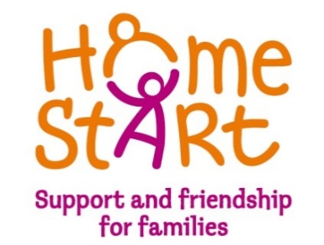

Sponsor a Family
Standing Order Mandate

Please complete, sign & return this form to your bank:

Please complete below boxes
Name of Account (as per cheque book)

Name of Bank

Branch

Sorting Code

Account Number

Email address

Please make arrangements to pay £ (amount in words ) immediately
or £ (amount in words) on of each month commencing until further notice
quoting reference (company name) to:

Unity Trust Bank
Account Number: 20247694
Sorting Code: 60-83-01
Account Name: Home-Start Knowsley Ltd

Signature: ………………………………………………………. Name in capital letters: ………………………………………

Position: ………………………………………………………… Date: …………………………………..

Address: ……………………………………………………………………………………………………………………………………….

……………………………………………………………………………………………………………………………………………

